Let's play the minesweeper game ([Wikipedia](https://en.wikipedia.org/wiki/Minesweeper_(video_game)), [online game](http://minesweeperonline.com/))!

You are given a 2D char matrix representing the game board. **'M'** represents an **unrevealed** mine, **'E'** represents an **unrevealed** empty square, **'B'** represents a **revealed** blank square that has no adjacent (above, below, left, right, and all 4 diagonals) mines, **digit** ('1' to '8') represents how many mines are adjacent to this **revealed** square, and finally **'X'** represents a **revealed** mine.

Now given the next click position (row and column indices) among all the **unrevealed** squares ('M' or 'E'), return the board after revealing this position according to the following rules:

1. If a mine ('M') is revealed, then the game is over - change it to **'X'**.
2. If an empty square ('E') with **no adjacent mines** is revealed, then change it to revealed blank ('B') and all of its adjacent **unrevealed** squares should be revealed recursively.
3. If an empty square ('E') with **at least one adjacent mine** is revealed, then change it to a digit ('1' to '8') representing the number of adjacent mines.
4. Return the board when no more squares will be revealed.

**Example 1:**

**Input:**

[['E', 'E', 'E', 'E', 'E'],

['E', 'E', 'M', 'E', 'E'],

['E', 'E', 'E', 'E', 'E'],

['E', 'E', 'E', 'E', 'E']]

Click : [3,0]

**Output:**

[['B', '1', 'E', '1', 'B'],

['B', '1', 'M', '1', 'B'],

['B', '1', '1', '1', 'B'],

['B', 'B', 'B', 'B', 'B']]

**Explanation:**

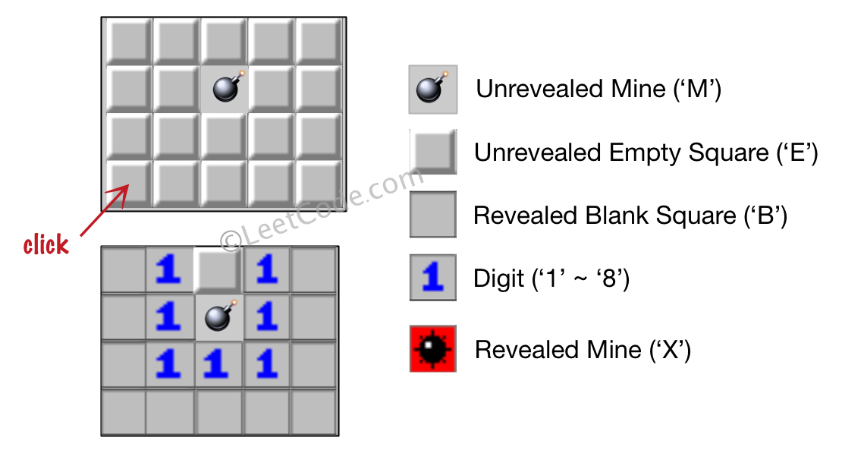

**Example 2:**

**Input:**

[['B', '1', 'E', '1', 'B'],

['B', '1', 'M', '1', 'B'],

['B', '1', '1', '1', 'B'],

['B', 'B', 'B', 'B', 'B']]

Click : [1,2]

**Output:**

[['B', '1', 'E', '1', 'B'],

['B', '1', 'X', '1', 'B'],

['B', '1', '1', '1', 'B'],

['B', 'B', 'B', 'B', 'B']]

**Explanation:**

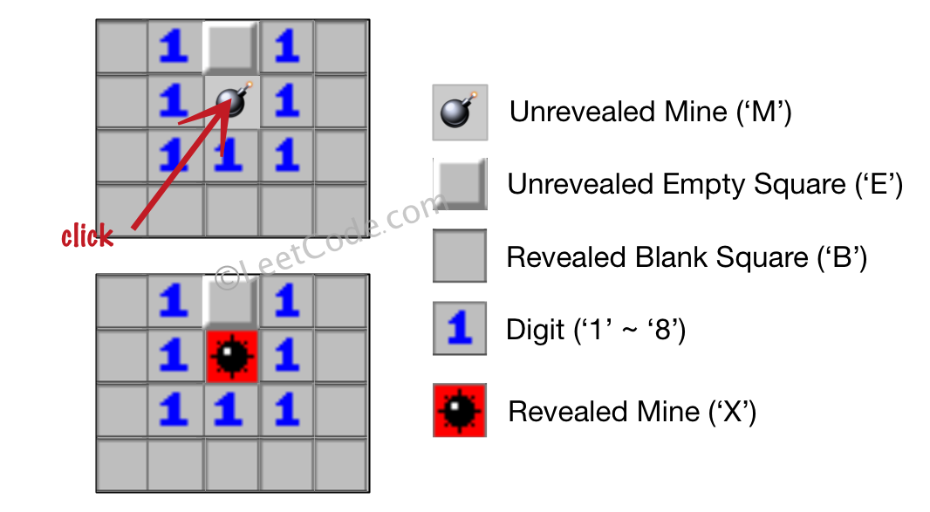

**Note:**

1. The range of the input matrix's height and width is [1,50].
2. The click position will only be an unrevealed square ('M' or 'E'), which also means the input board contains at least one clickable square.
3. The input board won't be a stage when game is over (some mines have been revealed).
4. For simplicity, not mentioned rules should be ignored in this problem. For example, you **don't** need to reveal all the unrevealed mines when the game is over, consider any cases that you will win the game or flag any squares.